**PRACTICAL 1**

Aim: To Create and Manage Vector data

1. **Adding Vector Layer**

Procedure:

* Creating Polygon vector Layer
* Open a New Project and Select Layer→Create Layer→New Shapefile Layer

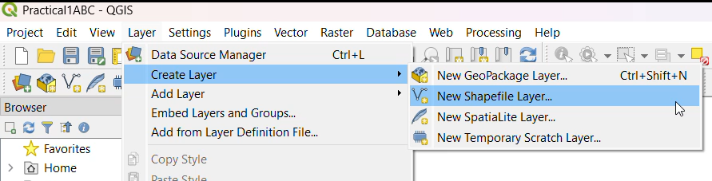

* Following dialog box will appear on the screen. Select Polygon option from Geometry type.
* Fill the appropriate information in each text box such as File name : By default the file will be saved in bin folder. To avoid it click on following button to change the location of file.
* Field Panel : Add the Attribute you want to show. (Column Name for Table). Specify Type (DataType:Text Data/Decimal Data/Whole Number/Date) of Attribute. Specify the Length of the Attribute. Specify Precision (If Data Type is Decimal)
* Click on Add to Field List Button

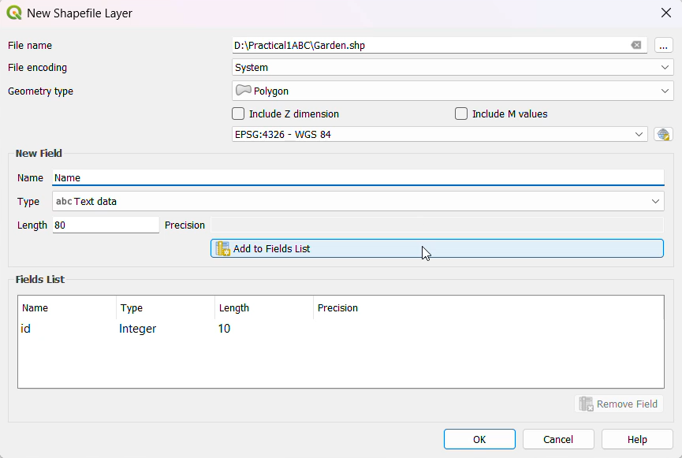

* Select Geometry Type as follows: Click on the following button. The CRS dialog box will appear on the screen. Click on the WGS84 option and it will be selected as follows. click on OK

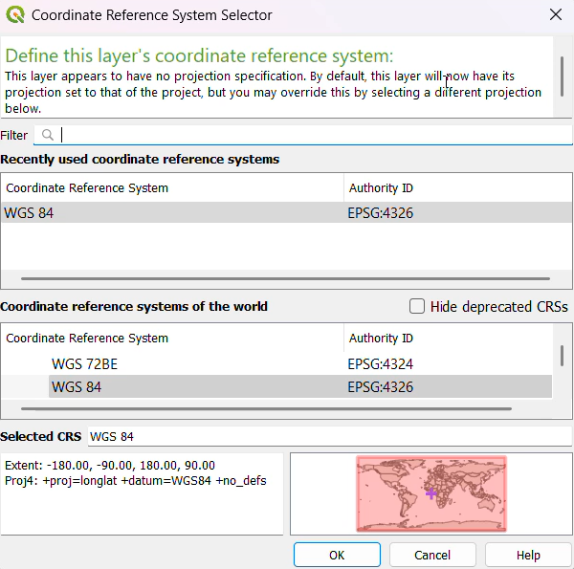

* Select the Polygon Feature from layer panel. Click Toggle Editing Button → Click on Add Polygon

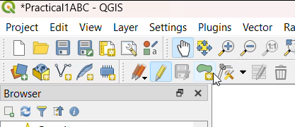

* Now place the cursor at the location where you want to place the polygon. for polygon layer minimum 3 points should be selected

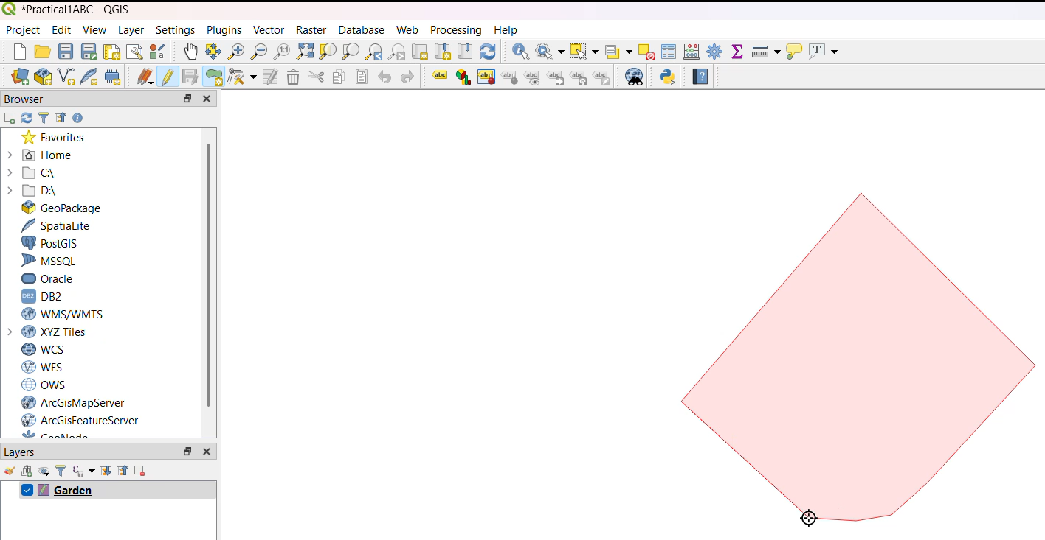

* Save the newly added polygon as follows.

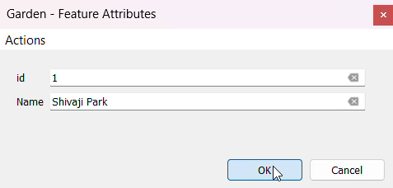

* Same way we can add one more polygon layer for Gardens.

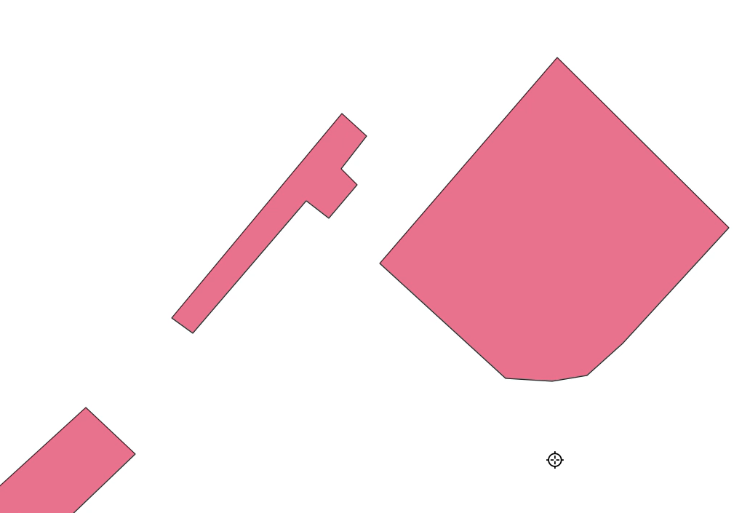

* Creating Line vector Layer
* Repeat the same steps as we have done for polygon layer.
* Select geometry type Line.

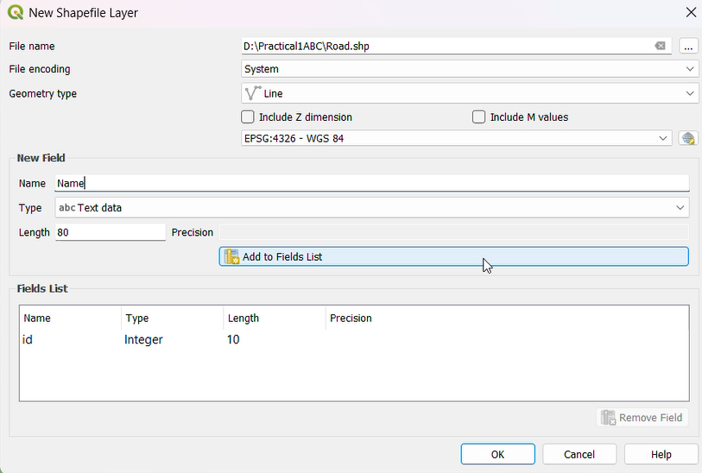

* To plot road click on Add Line Feature.

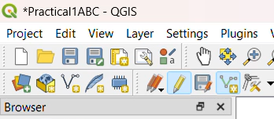

* Click on the map where you want to draw line. Once you are done then right click on map (Dotted line turn into solid line)

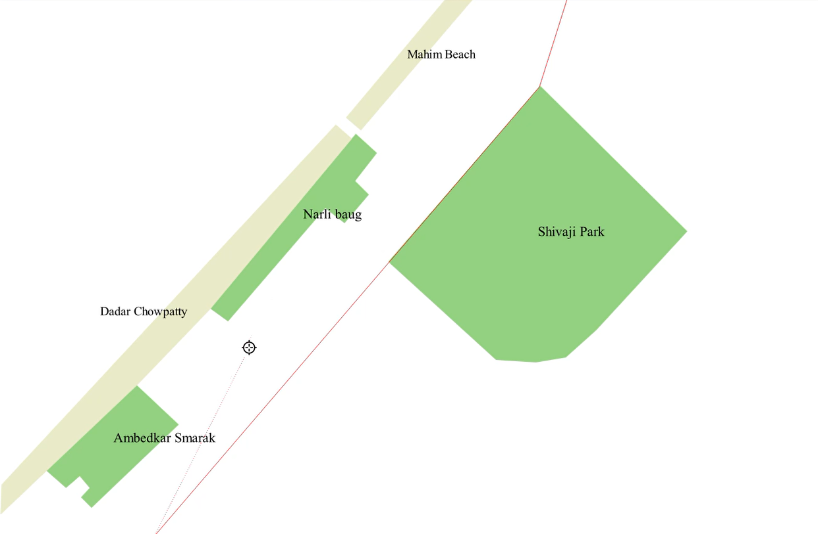

* Save the newly added Line as follows

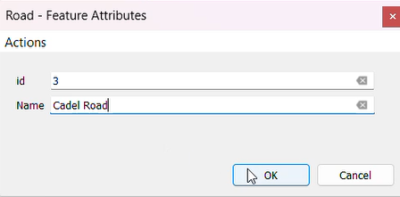

* Same way we can add one more Line layer for Roads

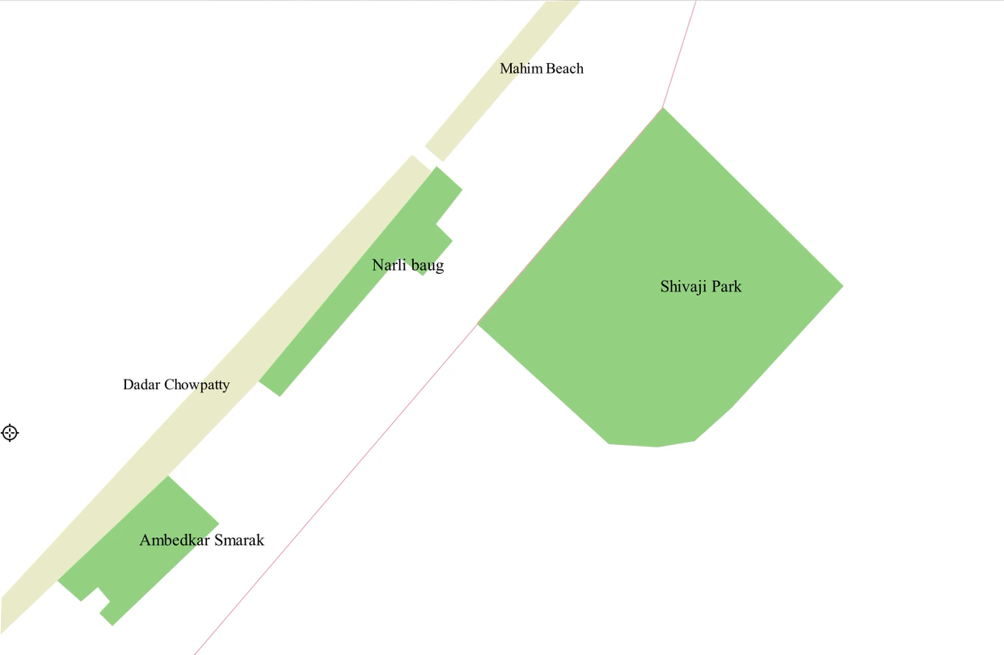

* Creating Point vector Layer
* Repeat the same steps as we have done for polygon and line layer.
* Select geometry type Point.

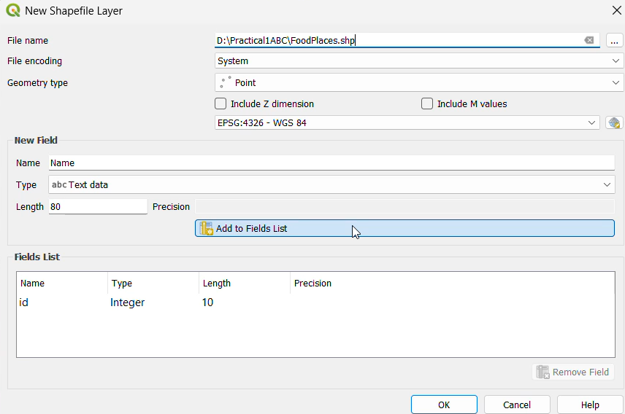

* To plot points click on Add Line Feature.

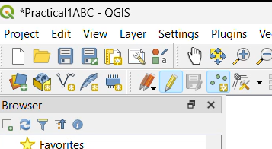

* Place the cursor on the map where you want to draw Points.

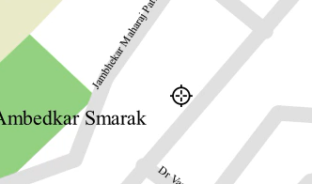

* Save the newly added Line as follows

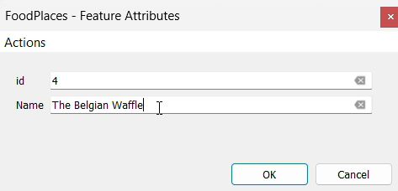

* Same way we can add one more Points layer for Places

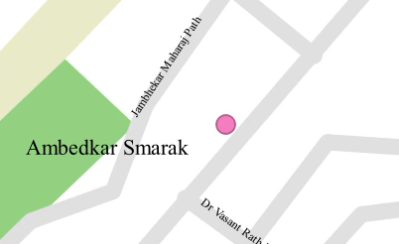

1. **Setting properties**

Procedure:

* Setting properties for polygons
* Set style for polygon by using property window(Right click on Garden Layer)

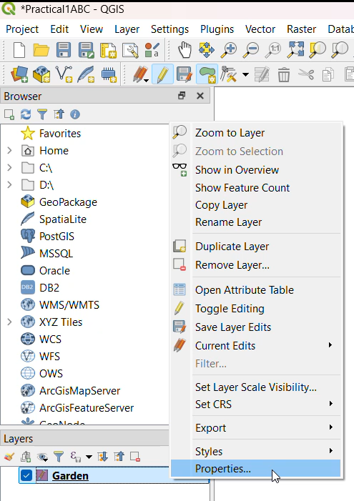

* Following screen will appear on the screen. Select pattern as you want and click on OK.

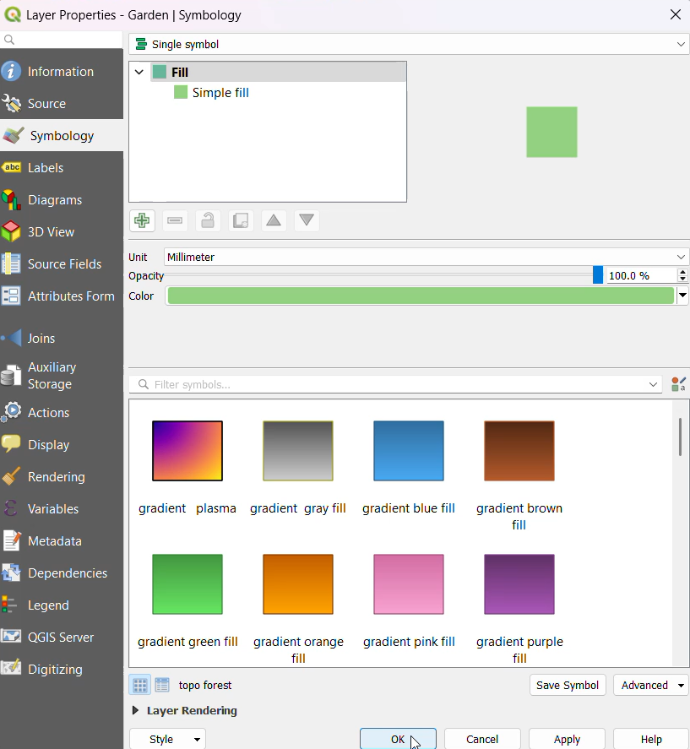

* To Label the Polygons Select Single labels→Select the field to Label with →OK

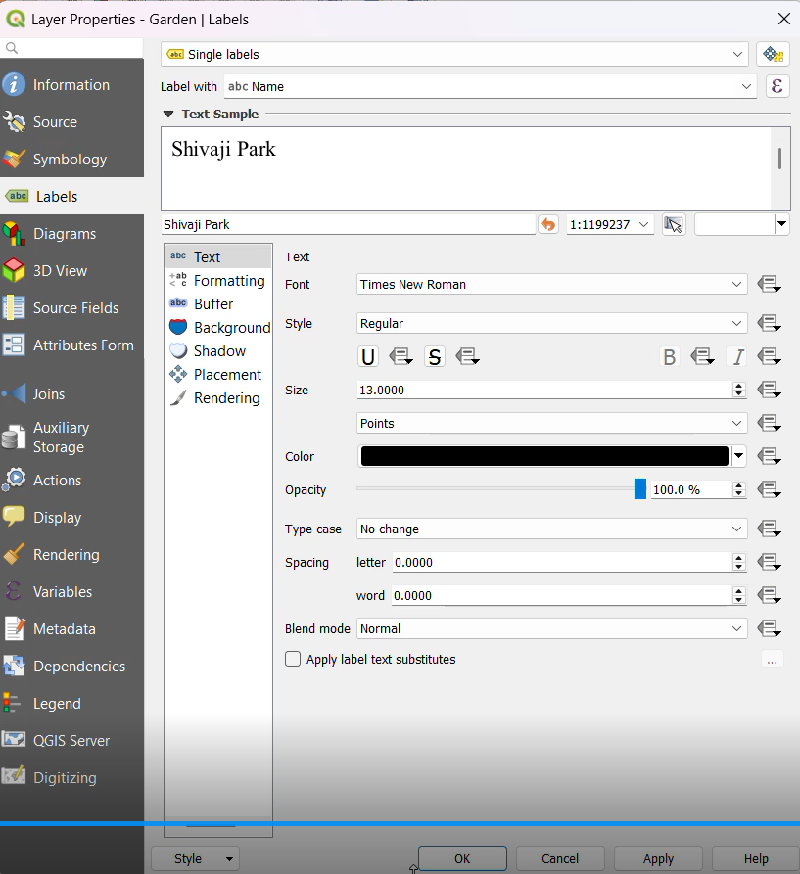

* The Layer will be set with the properties applied

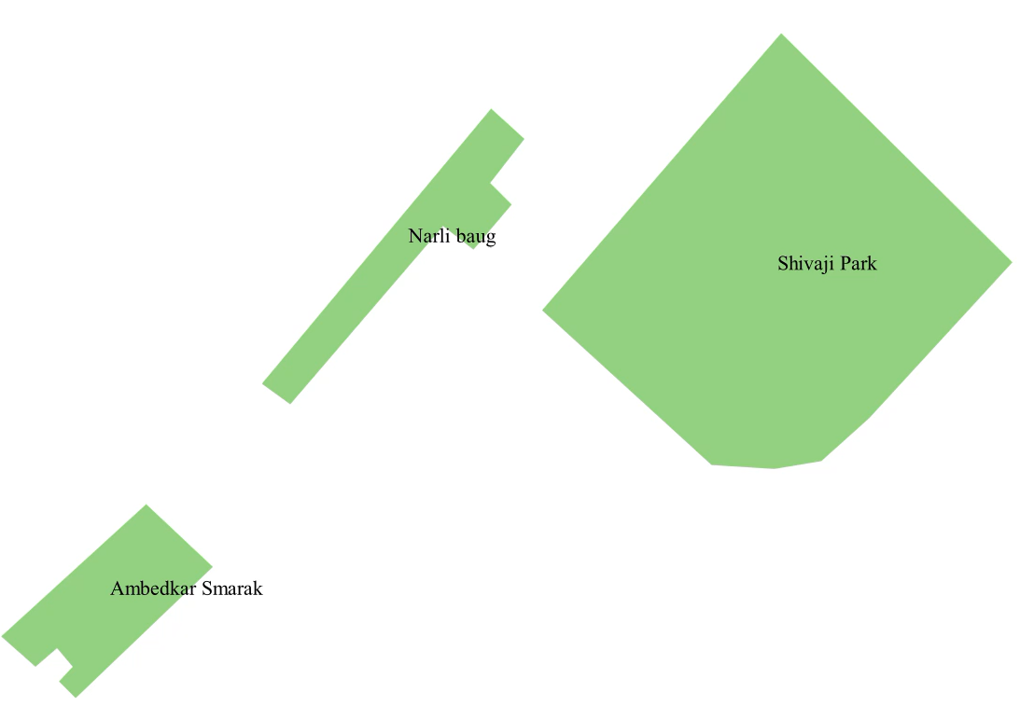

* Setting properties for lines
* Set the style for the line using the property window. The following screen will then appear. Select the pattern you want and click on OK.

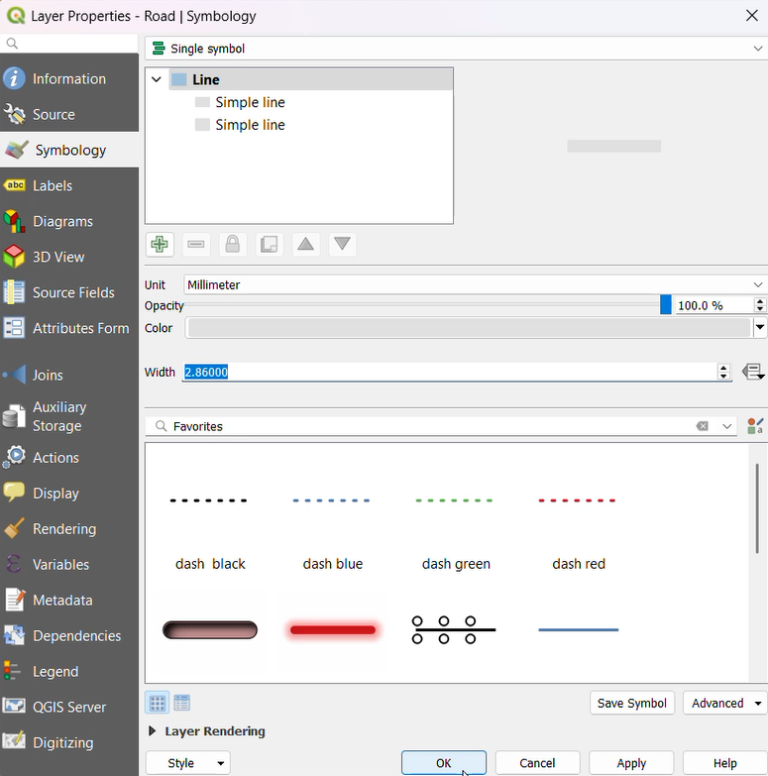

* To Label the lines Select Single labels→Select the field to Label with →OK

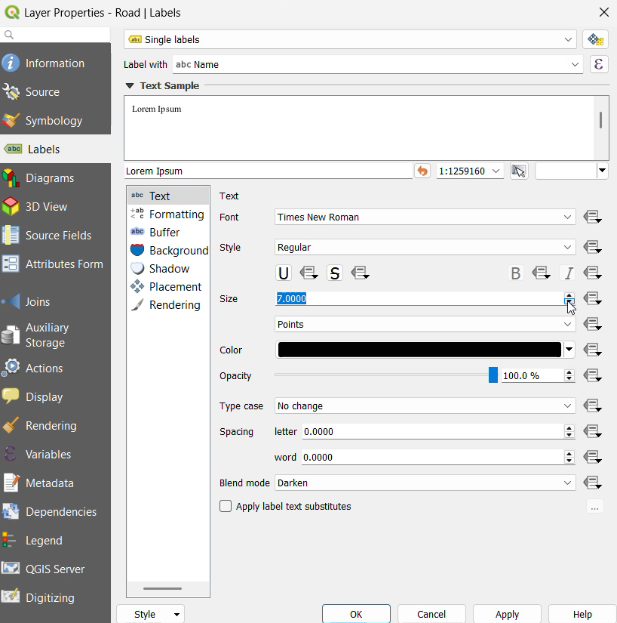

* The Layer will be set with the properties applied

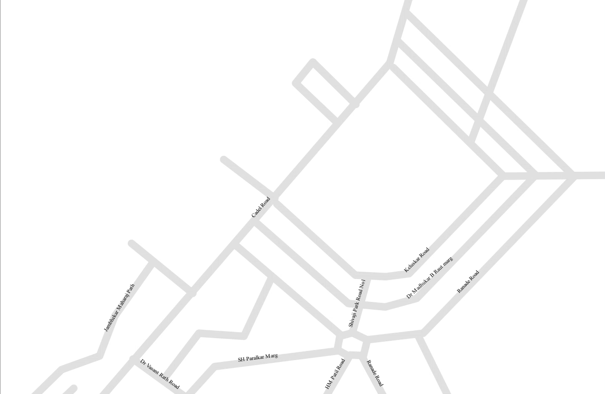

* Setting properties for points
* Set style for points by using property window then Following screen will appear on the screen. Select pattern as you want and click on 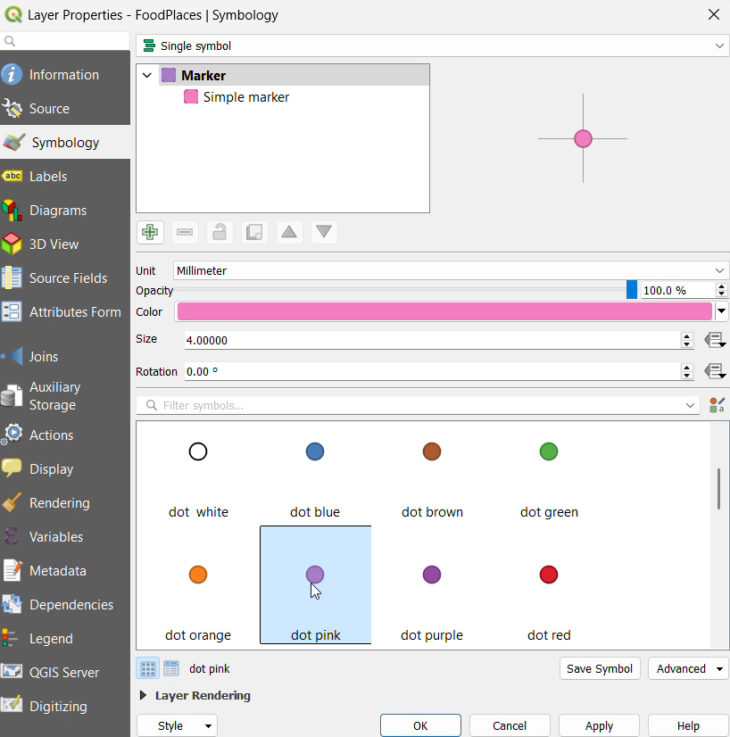
* To Label the points Select Single labels→Select the field to Label with →OK

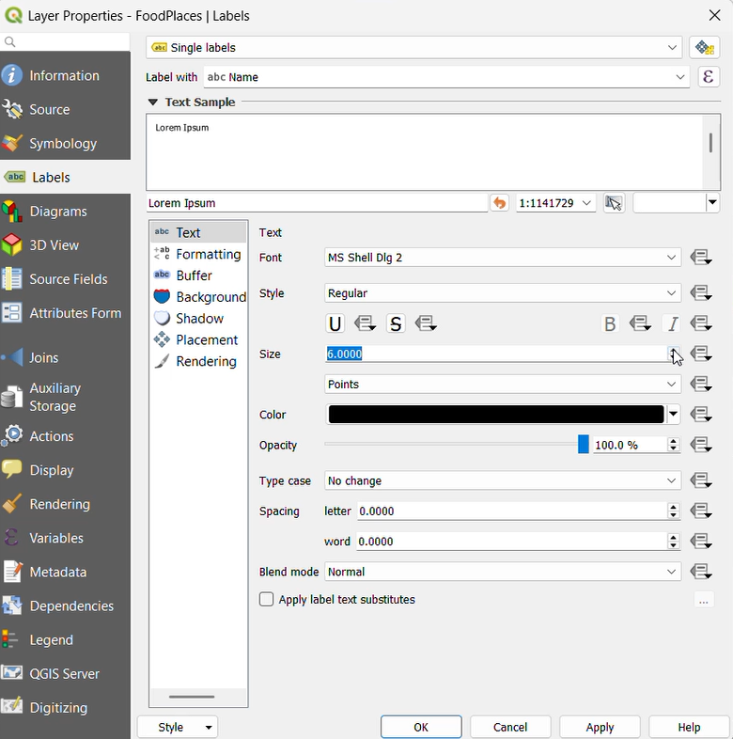

* The Layer will be set with the properties applied

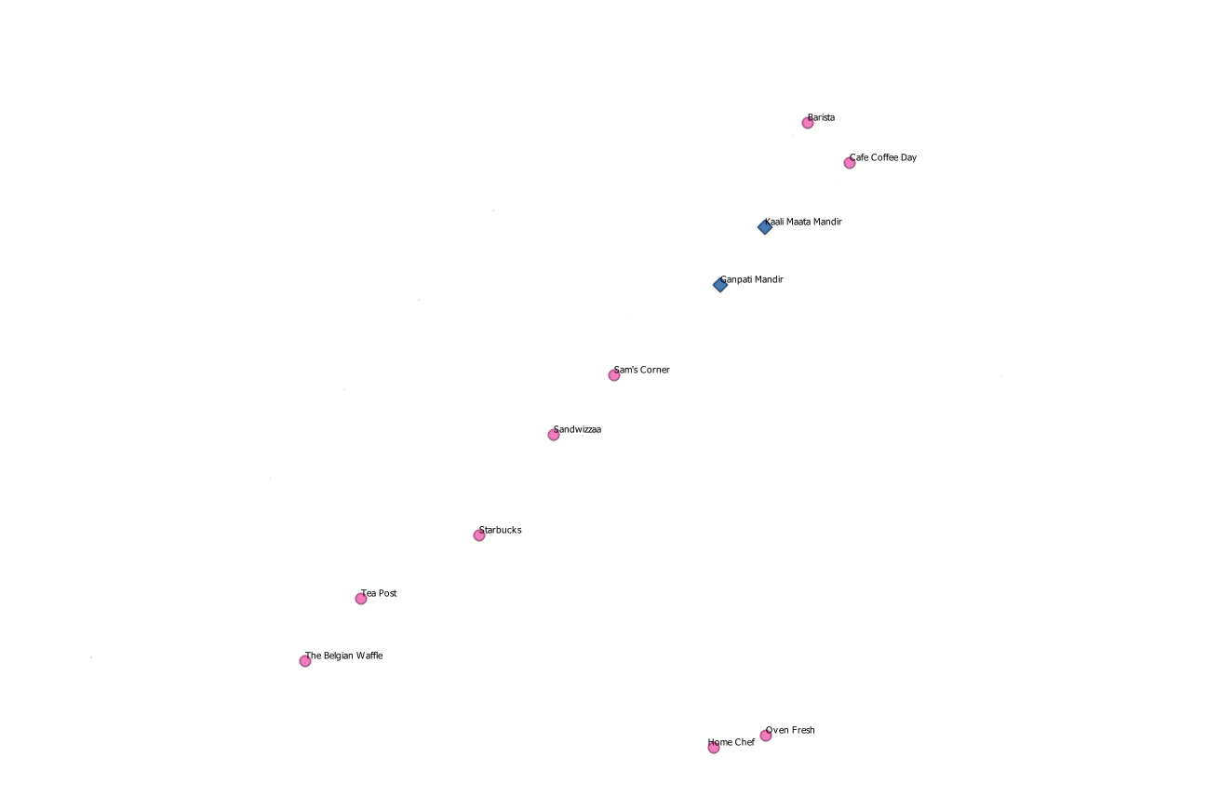

1. **Vector Layer Formatting**

* Creating Polygon Layers

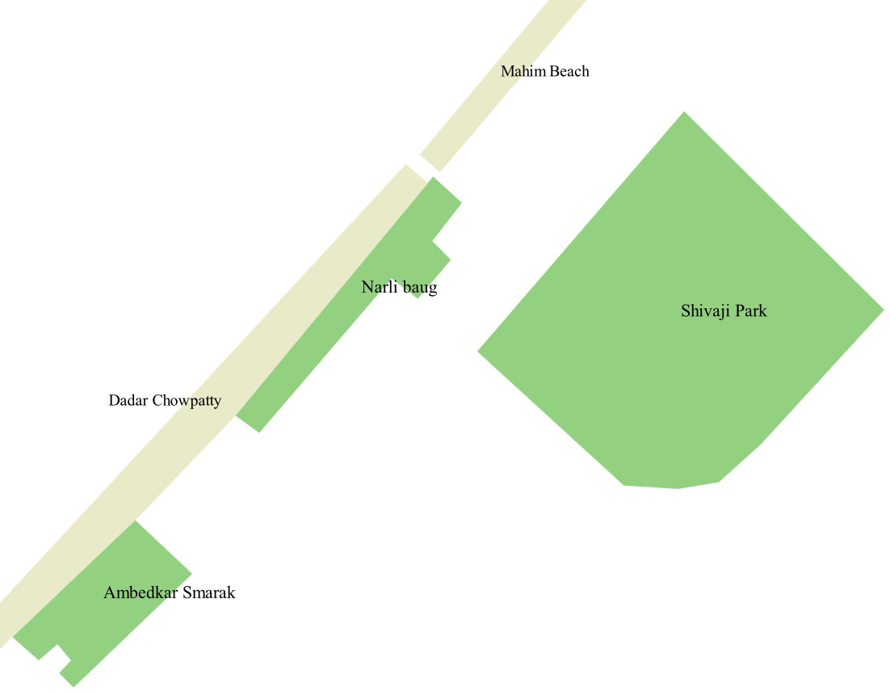

* Creating Line Layers



* Creating Point Layers



* Final Output:

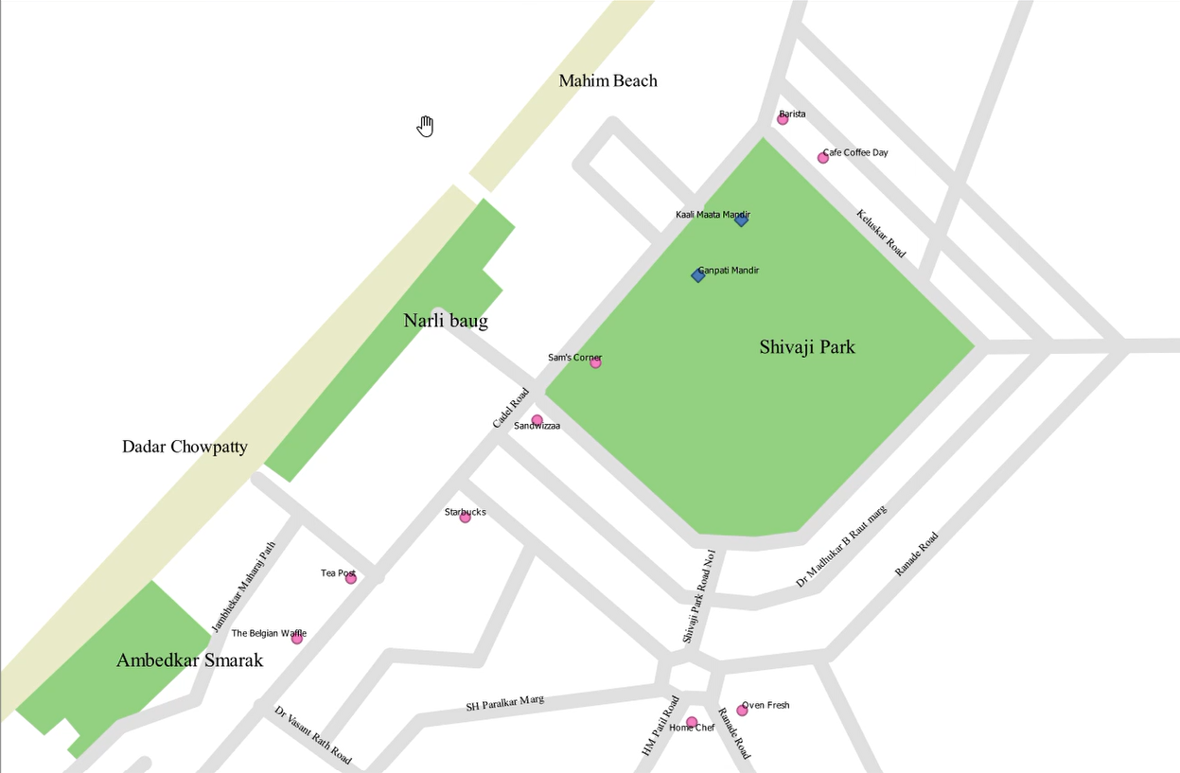

1. **Calculating line lengths and statistics**

Procedure:

* Go to Layer → Add Layer → Add Vector Layer

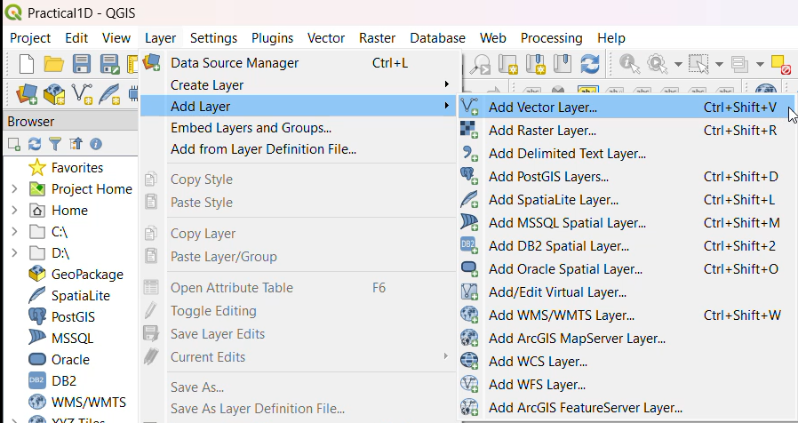

* Add the following file to project "\GIS_Workshop\Practicals\Practical_01\D\DATA\IND_rrd\IND_rails.shp" Press “ADD”
* Also add India Administrative Map “GIS_Workshop\Practicals\Practical_01\D\DATA\IND_adm\IND_adm0.sh”

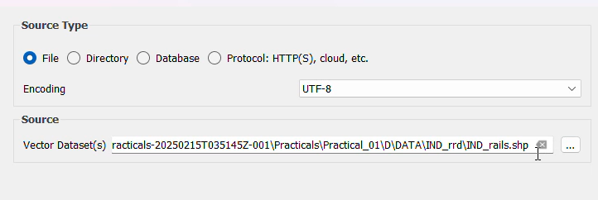

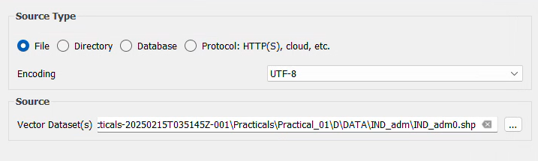

* Double Click on IND_adm0 Select → Select any outline style from below given options. Press OK.

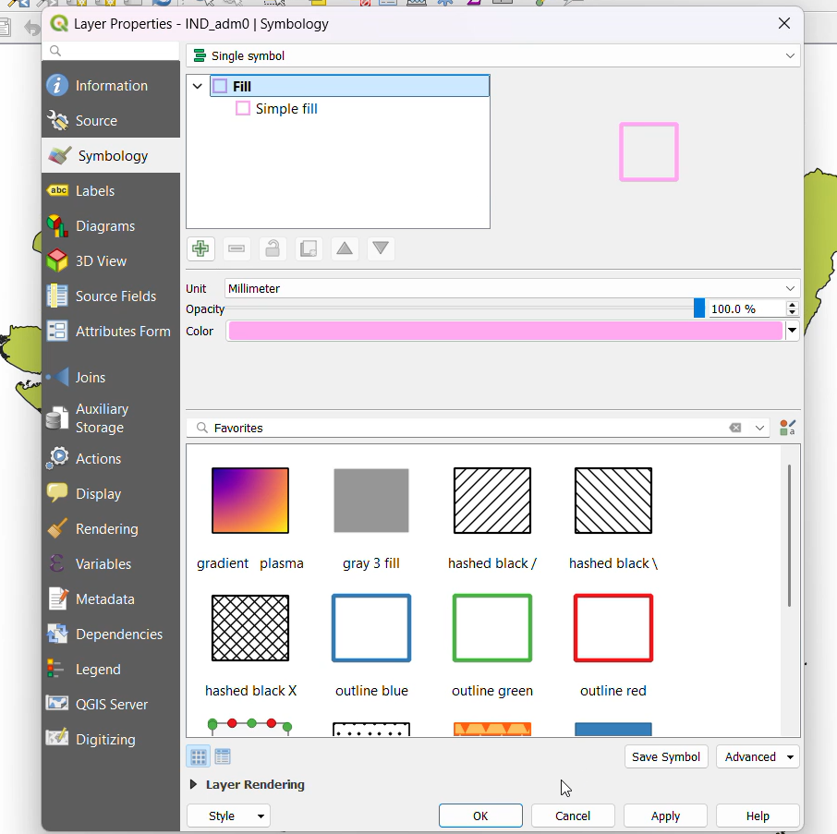

* In Layer Pane, Right click on IND_rails → Open Attribute Table

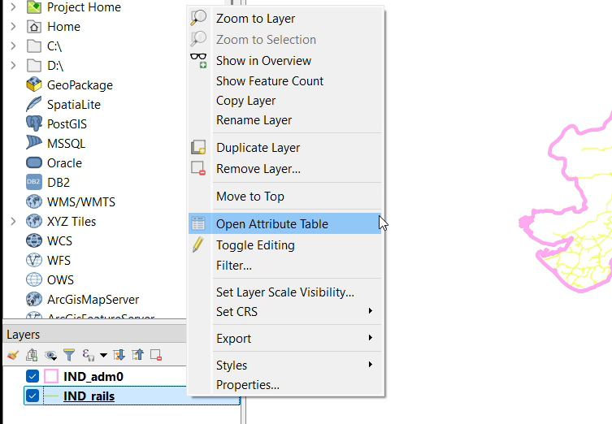

* Press Toggle Editing button, then on Attribute table window toolbar.

Press Open Field Calculator.

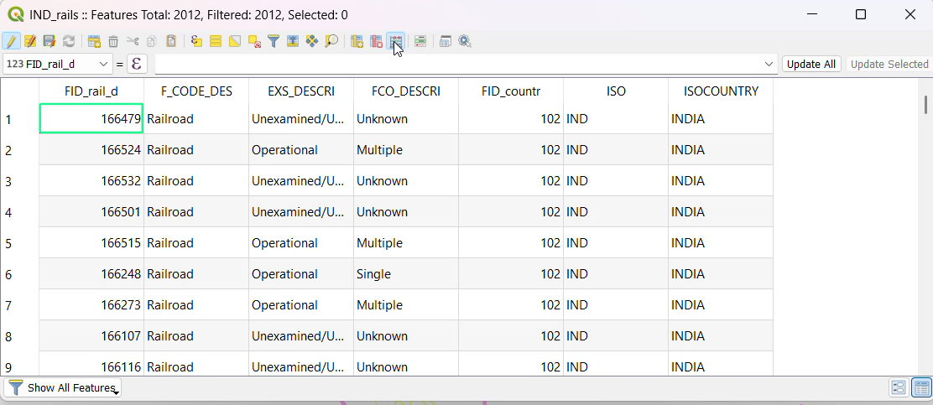

* Set the output field as “Track_Len”, field type to “Decimal Number”.
* From Function List search $length or go to Geometry → Select $length Set expression as following and Press “OK”

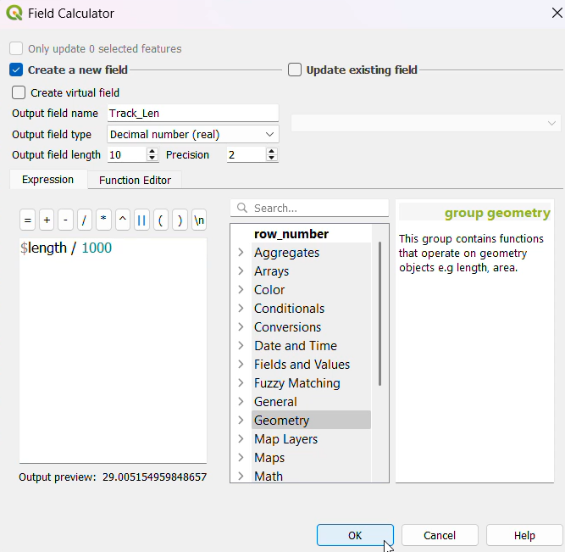

* A new column is added to the attribute table with value representing the length of track in KM. Press CTRL+S or click on Save Edits option on tool bar ➢ Close the attribute table window.

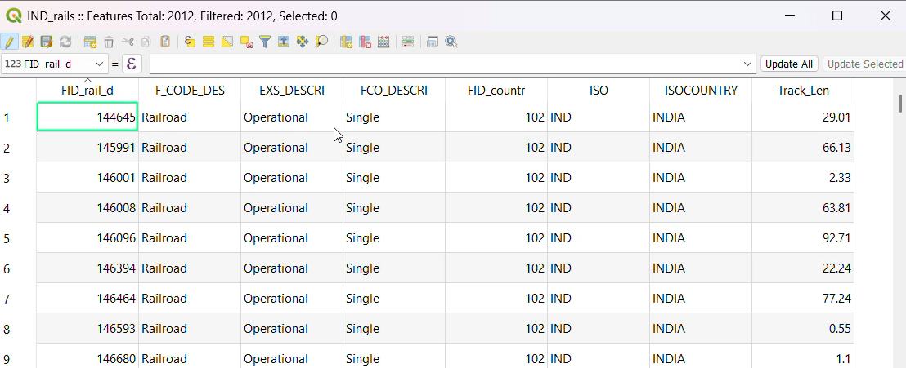

* For calculating the total length of Railway tracks in India. Select Vector→ Analysis Tools→ Basic Statics for Fields

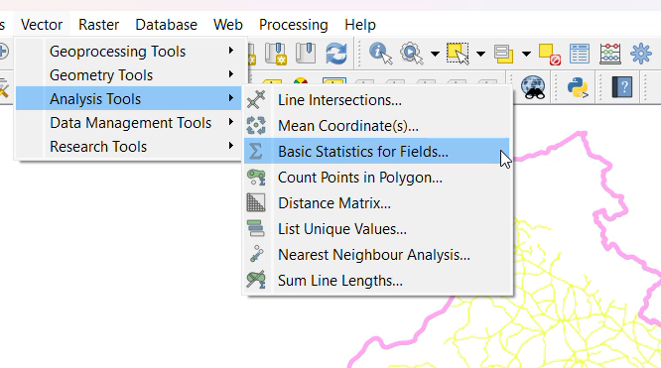

* Select IND_rails layer from input layer. And select Track_Len in “Field to Calculate statistics on”. Press RUN

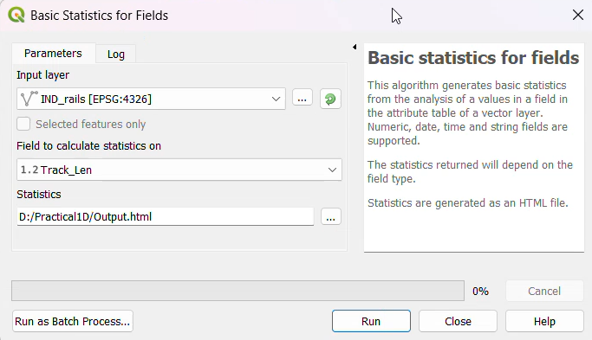

* The Result is as following.

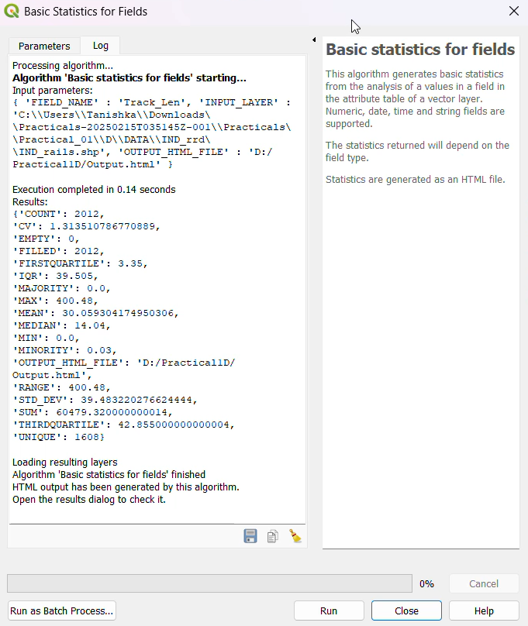

* Open the “output.html” file to get the field statistics.

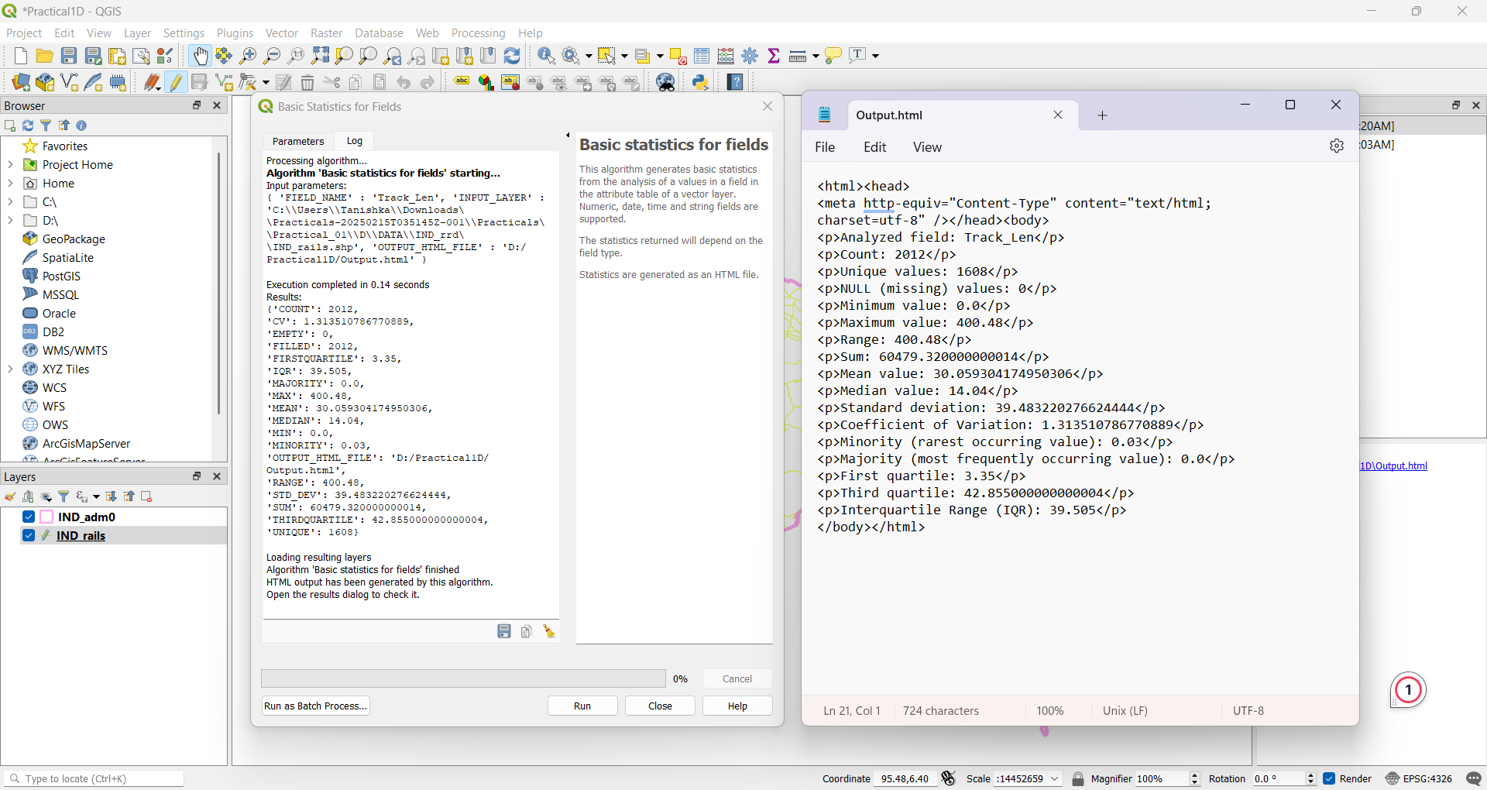

Output: Vector data has been created and managed successfully.